

FLYNN’S ARCADE

Ahmed. Hadi IST

**Design brief**

Flynn’s arcade is slowly losing money as the old generation of gaming is coming to an end arcade machines and social gaming is dying while consoles such as the ps4 & Xbox is rising. Flynn wants to change his business from an arcade to a venue for selling games and trading used games he has asked you to design and create an alpha phase website that communicates his new business model.

***Areas of investigation***

**Comparison of website creation tools**

Definitions

IDE. Ide or integrated Development Environment enables programmers to consolidate the different aspects of writing a computer program. IDE contains a code editor or a compiler that the user access through a single GUI (graphics user interface). An IDE has a compiler or code editor that helps coding syntax.

CMS. (Content management system) allows you to manage and control the content within your web page without technical training. You can very easily add, delete images and edit text in your web page on the go.

**DRAG AND DROP**. Is a website creator that makes making a website look like a babe’s game. It lets you create a professional website while not knowing a single piece of code, all you have to do is select a basic layout and drag pre-set to where you want them to go.

|  |  |  |
| --- | --- | --- |
| **IDE** | Image result for NetBeans**NetBeans** | NetBeans is an open-source integrated development environment (IDE) for developing with Java, PHP, C++, and other programming languages. NetBeans is also referred to as a platform of modular components used for developing Java desktop applications. |
| **CMS** | Image result for joomla logo**joomia** | Joomla is an open source platform on which Web sites and applications can be created. It is a content management system (CMS) which connects your site to a MySQLi, MySQL, or PostgreSQL database in order to make content management and delivery easier on both the site manager and visitor. |
| **DRAG AND DROP** | Image result for wix.com logo**wix** | Wix is a cloud-based drag and drop website builder that allows you to design and build your own website without needing to know how to code at all. |

Based on the research I have done and, in my opinion, out of these three website creation tools wix is the best go to option to use because wix is a free and it is very easy to use, wix has a cloud where all your work is out and stored in a server for you to use later, wix lets you create professional websites without knowing a single peace so code making you look like PRO.

**Background Research**

Flynn’s arcade is a friendly neighborhood gaming arcade owned and operated by Kevin Flynn. Kevin Flynn born in Paramus New Jersey in the year 1940 is a video game programmer that works for the company ECON, he creates many video games for the company. While he was working for the company Flynn started to create his own game in secret but while he was doing that another person that worked for the company Ed Dillinger found out about what Flynn was doing so, he stole his game and told the company he created it himself. Flynn was fired shortly after Dillinger became executive VP. After a while Flynn created TRON an arcade game based on his experience inside the computer world alongside the Tron program. Flynn created his own arcade calling it Flynn’s arcade and he put the game Tron in the arcade, meanwhile Flynn married Jordan canas and had a son named Sam, in 1985 Flynn’s wife had passed so Flynn focused all his efforts on creating a digital frontier to reshape the human conditions.1986 Flynn was on the verge of something new when he mysteriously disappeared and left behind Sam and his fortune. On the anniversary of his father’s disappearance Sam broke into an ECON tower an hacked the mainframe of the company, he leaked one of the company’s newest operation system (OS 12) onto the internet, while trying to escape Sam was captured by the police. When he got released from jail, he went back to his apartment finding Alan Bradley waiting for him, Alan told Sam that he had gotten a message on his pager from the telephone number Flynn’s arcade a number that has been down for years. Sam went to the arcade to check out what is happening, he found a hidden office behind the arcade game Tron in he office there was a laser and when Sam triggered the laser, he found himself teleported to the Tron system.

**Research on data communications and its implications for web design**

What are data communications?

Data communication is basically the process of sharing a message. A conversation between two people is one of the examples of data communication, it mostly relates to the sharing of a virtual message like emails and instant messages, as well as phone calls. For data communication you need a transmitter, the data your trying to send and a receiver. Take a message for example, the message your trying to send is the data, the device your writing it on is the transmitter and the person the device that gets the message is the receiver.

**Research on data communications and its implications for web design**

Data communications plays a big part in web design, every website has to have a communication for example every website has a contacts page and from the contacts page you can communicate with the compony for any problems or information you need. Many websites also have the future of text, if you have anything that you would like to say to the company there is always a way where you can text them or send an email. Text is one of the many type of communications used in web pages, another way of communication is how the website looks like colors, contents and more some websites try to communicate with visitors using only content or trying to send out a message. Over all communication is an important part of a website and most websites have it and should have it.

**Design sketches**

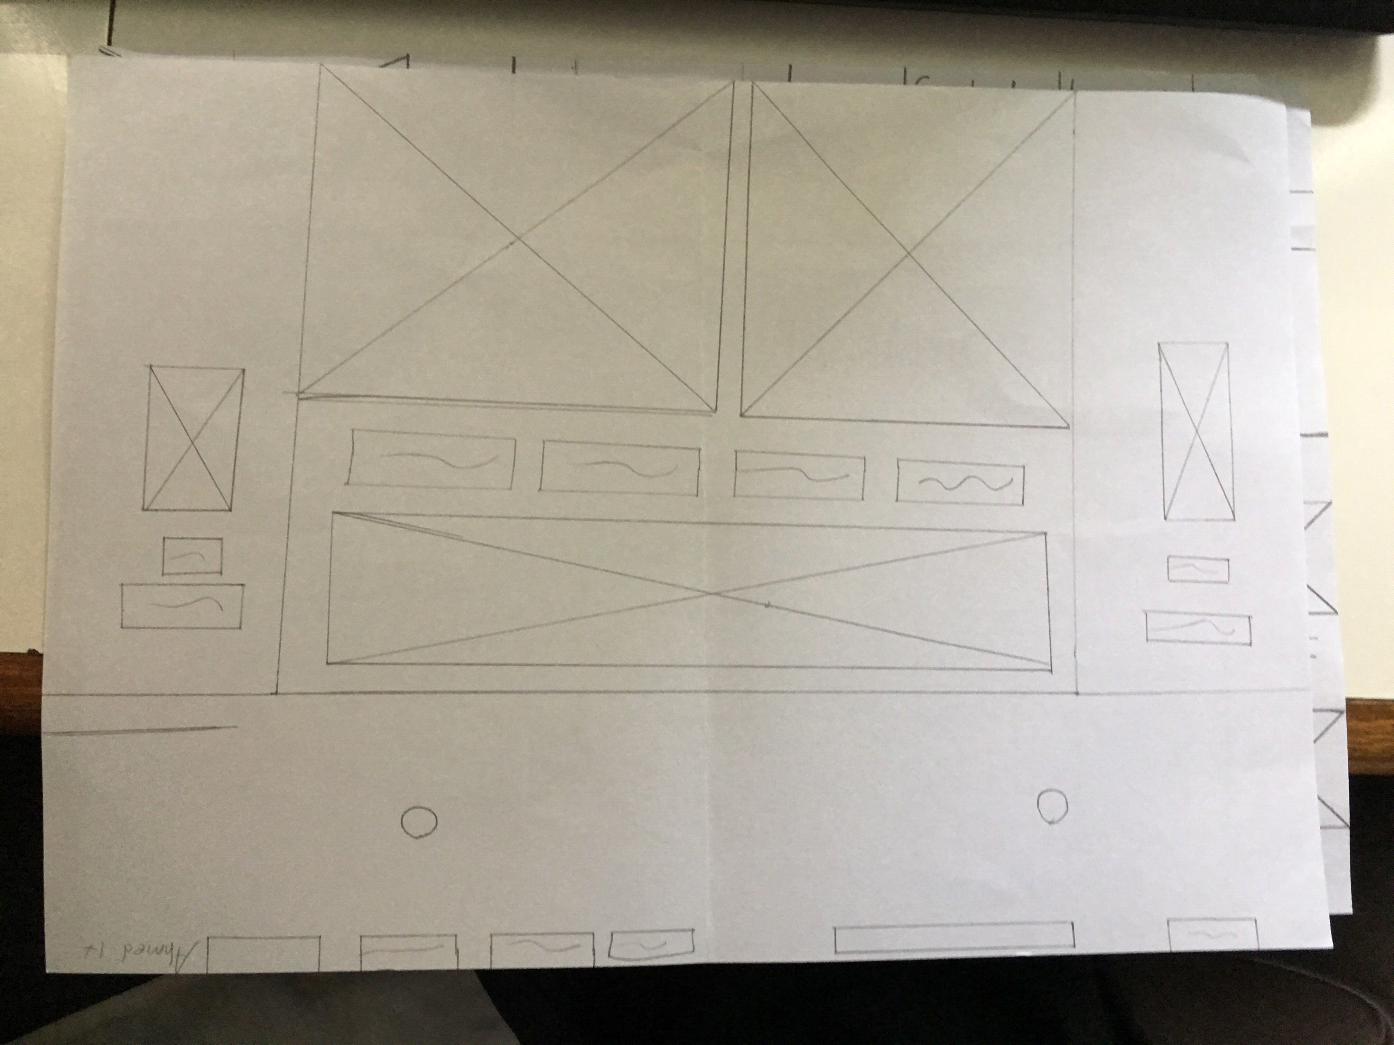

Design sketch 1

This is my first design sketch in the design sketch we had to hand draw a version of our website on paper and at the end we had to pick a version that we liked and implicated it in our website. In this one I done a simple website a got ideas from jb hi fi and EB games, I put a slider with content in the bottom and a logo with drop down buttons at the top.

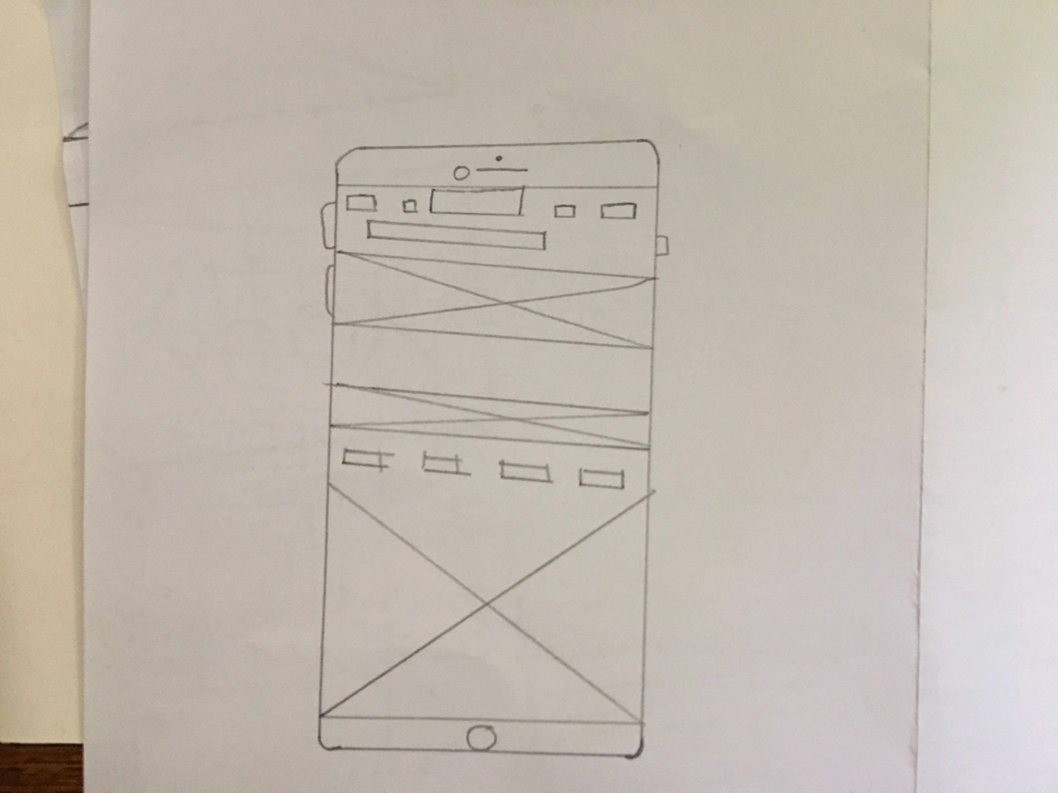

Design sketch 2

We had to draw another sketch but in this one we had to make it in a phone so if our websites where opened in a phone we would know what it looks like. For this one done the same concept for my first one, I went on jb hi fi and EB games on my phone to see how it looked and get ideas, I got drop bars on the top and a slide with content at the bottom.

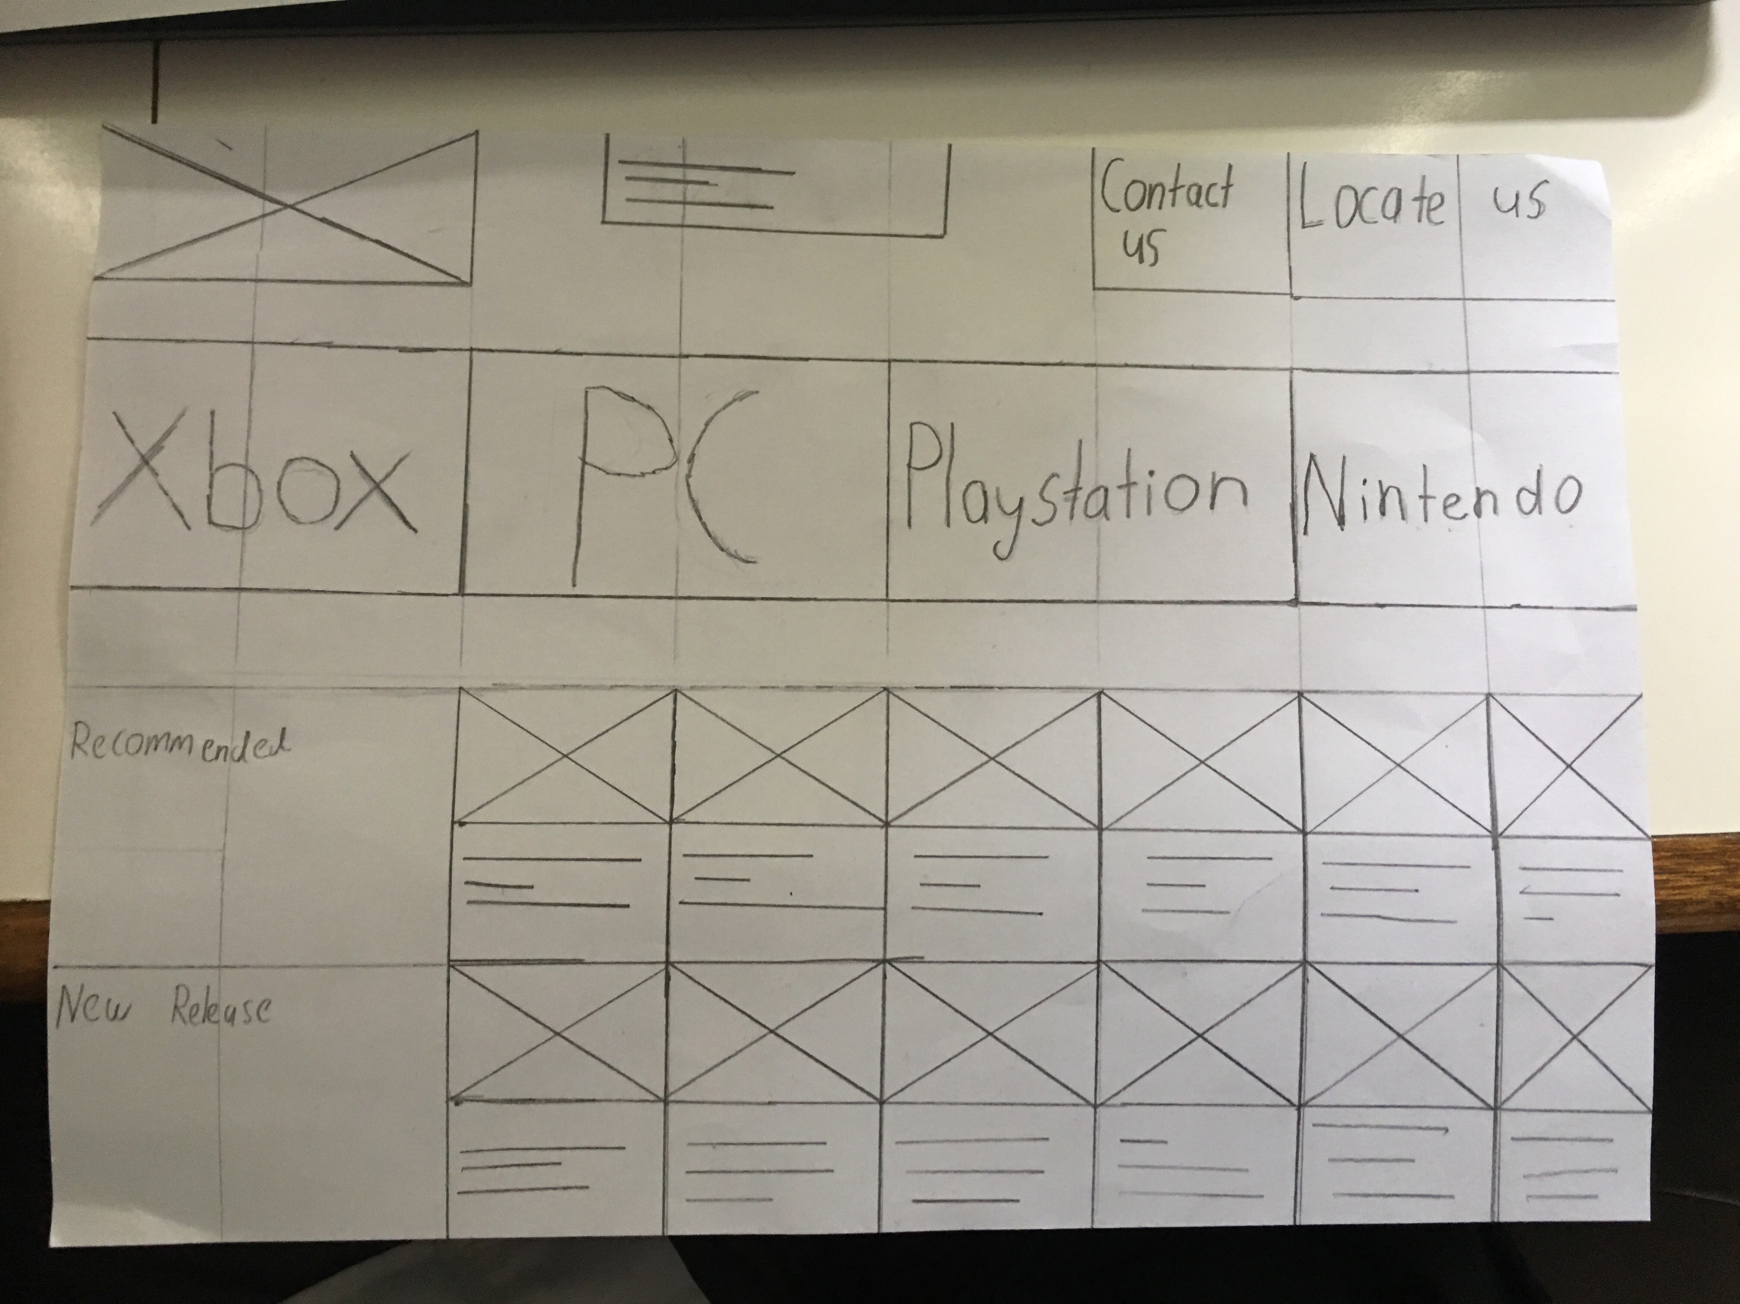

**Design sketches**

Design sketch 3

This is the third design we had to create, in this one we had to create our drawing neat with a ruler and make it look better then the other to because this might be our final design.

**Final concept design**



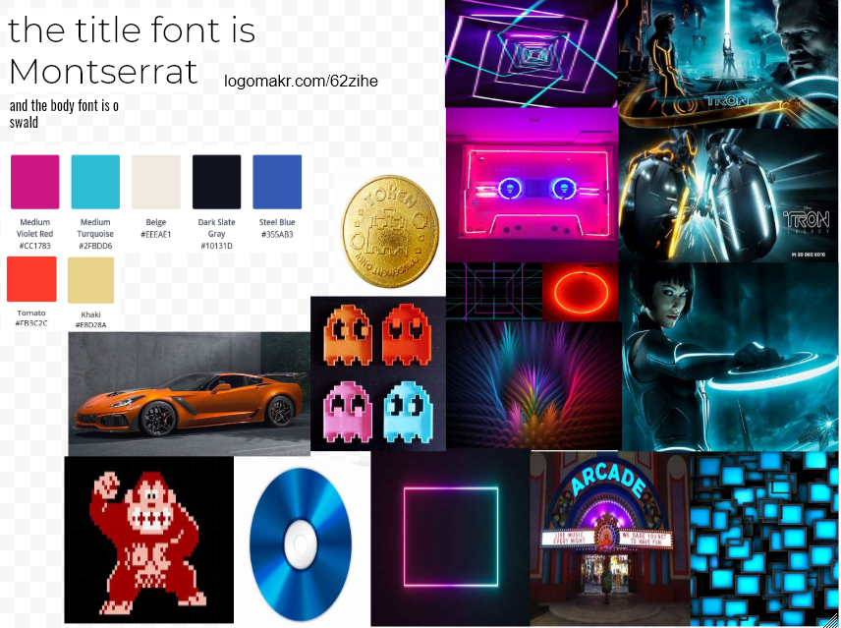

**Final product**

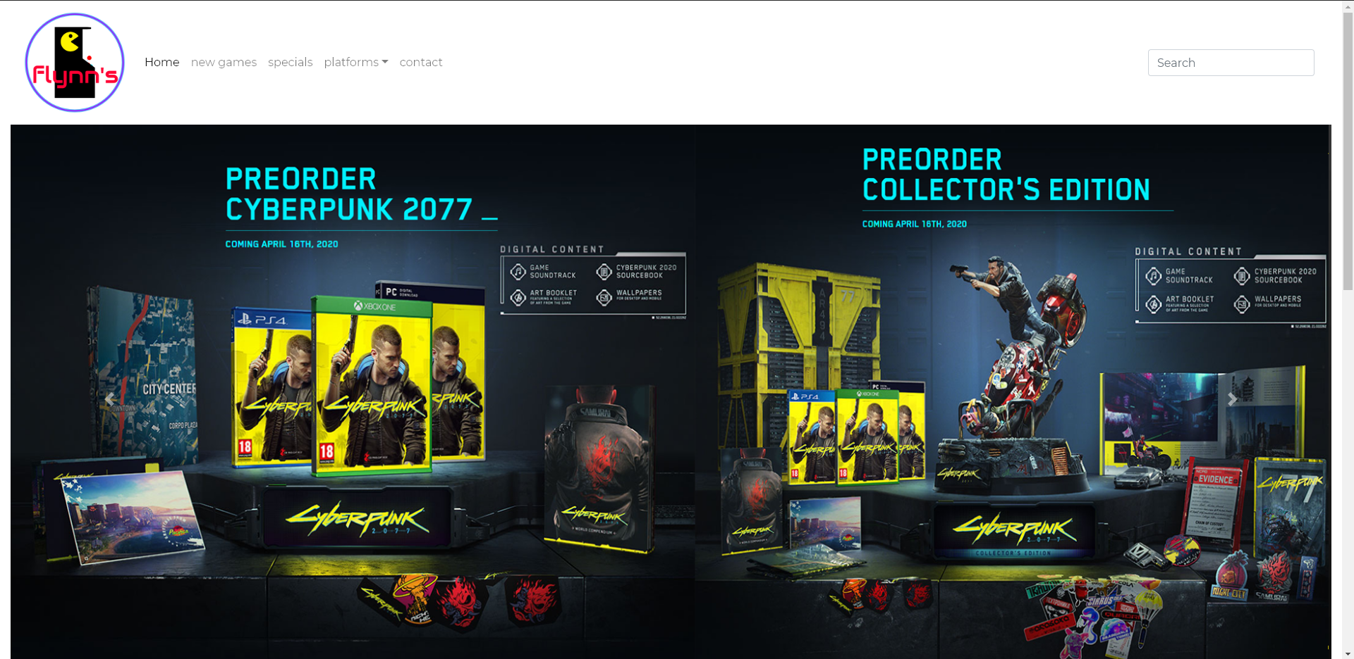

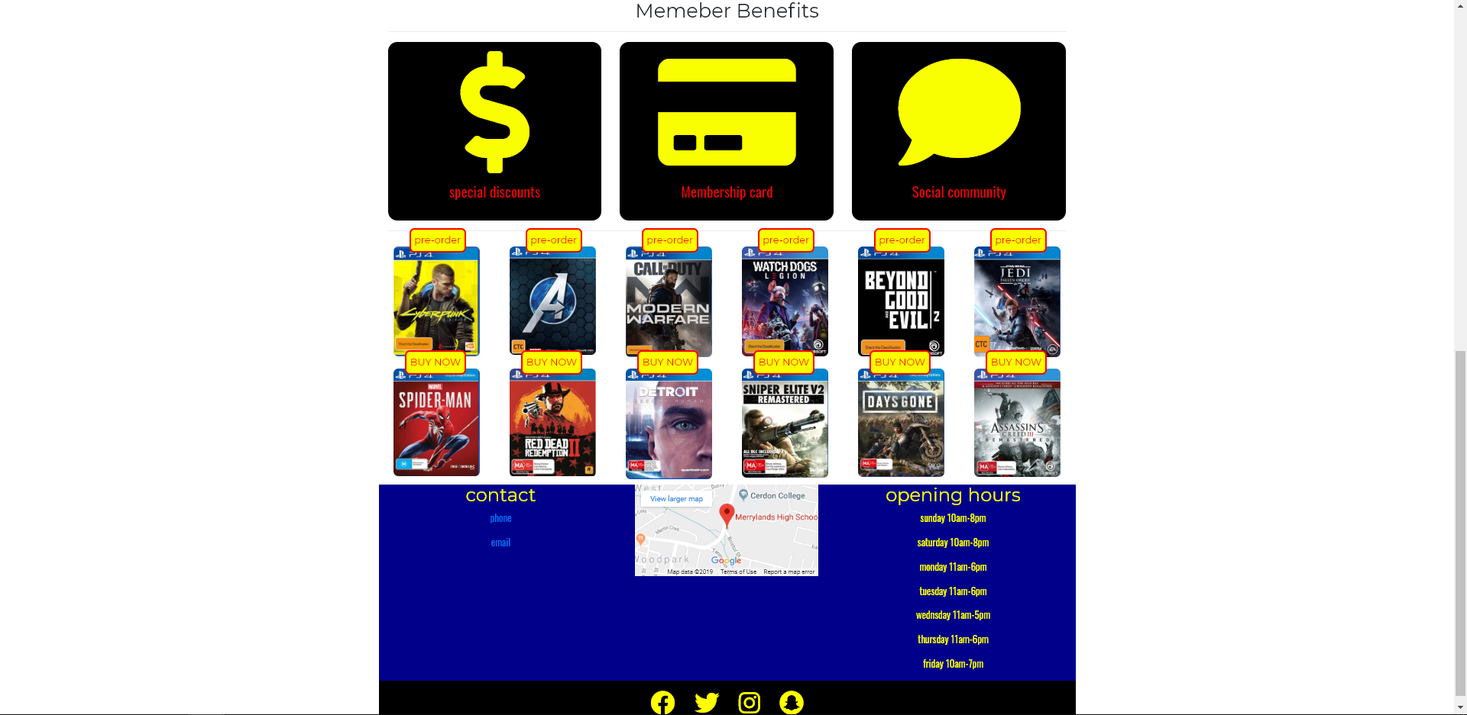

**Design changed**

As you can see there is a lot of difference between my concept design and my final product and I will explain why. First I will start with talking about my logo and why I made it look that way I made my logo look like an arcade game because the whole website that in creating is about games so I put an arcade machine to represent the old school of gaming and how it changed. The first change I made was the ps4, Xbox, pc and intend location, instead of just putting it at the top I created a drop down menu for It done that because sir told us to do it that way and I did what he said but at the end it looked very nice so I kept it how it was, I also changed the whole top of the website instead of making them all separated I connected them together. I added a slider to it because in the concept design I did not know that I needed a slider and I didn’t think it would look good but then after two lessons of using Photoshop to create a slider and editing it I finally found the best slider with the best image. I added three member benefits so that when people become a member they will have special discounts and other benefits, I found three logos to represent my three benefits I turn them yellow made them big and put It in the middle of the webpage. My color code is also very different to my sitemap, at the start I was going for a neon Tron look so that it represents Flynn’s arcade, blue neon and orange neon I tried these two colors many times trying to make them fit in with the sliders and the other element but it did not look good at all so I gave up and changed the colors to black yellow and blue because my slider and my logo had these colors in it.

Instead of having a recommend and new release rows for the games I changed it to buy now and pre-order because I had a slider about all the new upcoming games to pre-order but I didn’t have an actual place where I can pre-order it so I put a row with some of the games you can pre-order and gave it a button to make it look legit. The contacts is at the bottom but in my design sketch It was a the top, that was done because I went to other gaming web pages like eb games and jb hi fi and all there contacts was either in another page or at the bottom of the page so I put mine at the bottom with the opening hours and ways to contact us, there is a map linked to the contacts to show the locations of the stores and our Instagram/twitter/Facebook and snapchat link all the way at the bottom.

At the end I really like how it turned am happy that I didn’t just leave it like how I imaged it and changed it to something much better. That one of the best things in programming as you go you take a deep look at your programs and you decide to change something then you change another thing then on other till making it perfect to be proud of it.

**Evaluation**

My web page turned out really great like I said but there is always just some stuff you wish you had added and some improvements to your web site and there is always good and bad features of your web page. For example I really love my slider and how much detail there is I it is color coded to my whole website and it gives the sense that I actually cared about it but I wish that instead of just doing two sliders I should have done like 1 or 2 more and make then color coded as will just like the others and link them up in a sort of way. For my games about the bottom they all look perfectly in place but for the reason the button is at the top instead of the bottom it looks good but the button does not go anywhere when you press it but it makes a cool color change when you hover over it, I wish that I did link to a place where it says the price and a place to buy it, I can’t really do that because I’m not the experienced maybe I will do that next time.

My contacts page is all the way down and I have a button that say contacts at the top we had to create a hyper link so when you press that it will take you to a whole different page with the contacts in it, I did not have enough time to do that and I wish that I had done it so that my webpage is not just all in one page that makes it very boring and simple. Same thing with my slide down menu with the ps4, Xbox, pc and Nintendo I should have created a page where when you press on one of the platforms it would take you to a place where you can purchase one of the platforms or buy games for them, that would have been really hard to create but if I was able to accomplish it my webpage would have been way better then it is.

Overall some stuff are really will done and some stuff are barely tried on I should have waited and thought about everything take a deep breath and include more stuff to make my website go from 10 to 100 and give myself the sense of that I done good and that I tried my best. As I said it turned out ok and it was a really create and fun experience but it was a very hard journey to get to where I am right now and I hope everything goes as I planned and I get to finish this portfolio on time.

**Bibliography**

<https://tron.fandom.com/wiki/Flynn's_Arcade>

<https://tron.fandom.com/wiki/Sam_Flynn>

<https://tron.fandom.com/wiki/Kevin_Flynn>

<https://www.theserverside.com/definition/NetBeans>

<https://whatis.techtarget.com/definition/Joomla>

<https://whatis.techtarget.com/search/query?q=wix.com>

<https://en.wikipedia.org/wiki/WiX>

<http://ecomputernotes.com/computernetworkingnotes/communication-networks/what-is-data-communication>